**Setting Up Print/Cut Decals for Production**

**Step 1 – Open your working Illustrator file**

**Step 2 – Create different layers to organize your work**

1. Press the + to add a new layer, then double click the layer name and rename it **“Bleed”**

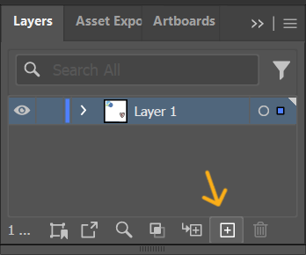

1. Follow this same process to create two other layers named **“Art”** and **“Cut”** respectively

1. Select your to-scale artwork with the Selection tool and put it in the “Art” layer by pressing Ctrl/Cmd + X, clicking on the “Art” layer, then pressing Ctrl/Cmd + V

**Step 3 – Expand artwork (If art contains strokes or live text)**

1. With your artwork selected, make sure any strokes or live text are converted to raw vector by going to Object > Expand Appearance, then Object > Expand
2. In the dialog box that pops up, make sure only the **Object** and **Stroke** boxes are checked and click Okay

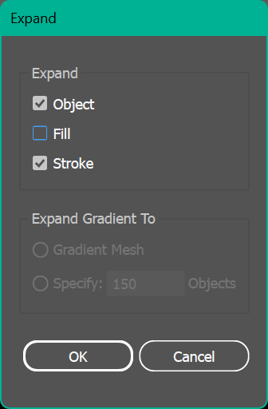

1. Repeat Object > Expand if there are still strokes that haven’t been outlined.

**Step 4 – Add bleed**

1. Navigate to Object > Path > Offset Path

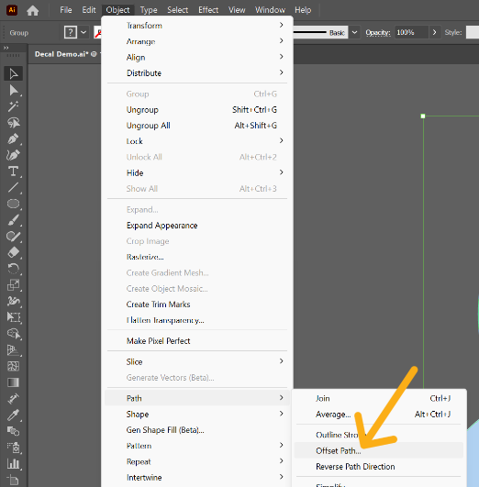

1. In the dialog box that appears, set the **Offset** to **0.08”** and the **Joints** to **Round**
2. The new paths should be selected; place them in the “Bleed” Layer by pressing Ctrl/Cmd + X, clicking on the “Bleed” layer, then pressing Ctrl/Cmd + Shift + V to paste in place
3. Press Ctrl/Cmd + G to group the bleed

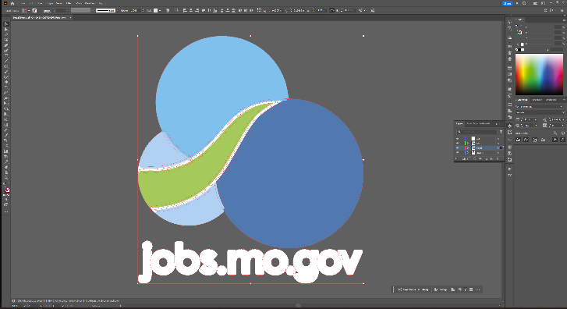

**Step 3 – Add Cut Lines**

1. Select your original art once again and copy it into the “Cut” layer by pressing Ctrl/Cmd + C, clicking on the “Cut” layer, then pressing Ctrl/Cmd + V
2. Use **Pathfinder** to combine your objects with **Unite** option

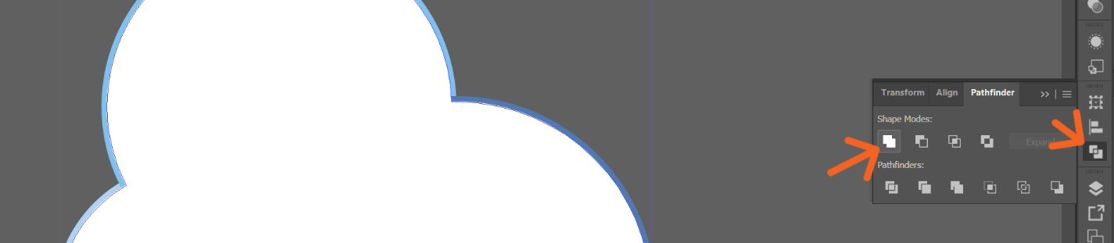

1. Set the fill of your new path to None, then stroke color and to **CMYK Magenta** and click the + at the bottom right to create a new swatch

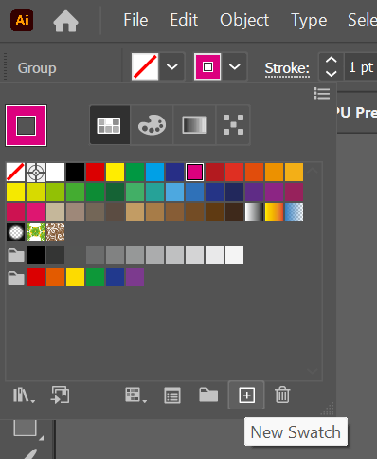

1. A dialog box will appear. Change the Swatch name to “**CutContour”** and the Color Type to **Spot Color**

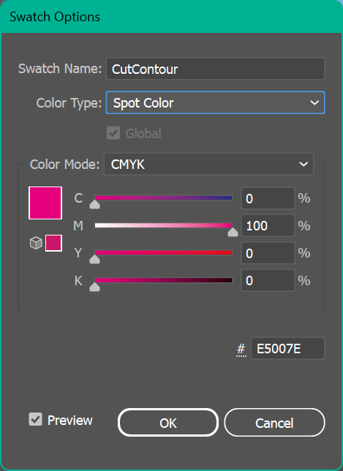

**Step 5 – Correct Bleed (if necessary)**

1. Lock the “Cut” and “Art” layers by clicking in the space to the right of the Visibility Toggle on each layer

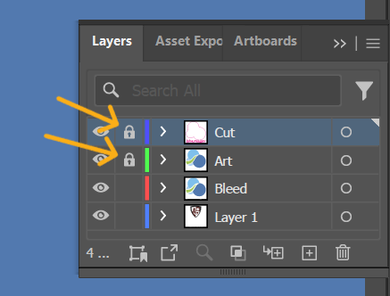

1. Examine the bleed against the art looking for any problem areas, such as:
   1. Intersecting colors
   2. Mismatched gradients
   3. Objects closer than 0.16” causing overlapping bleed
2. Use any tools necessary to correct inconsistencies
   1. Including but not limited to the Direct Selection and Pen tools to miter the bleed in corners and fix inconsistent color intersections

Before / After

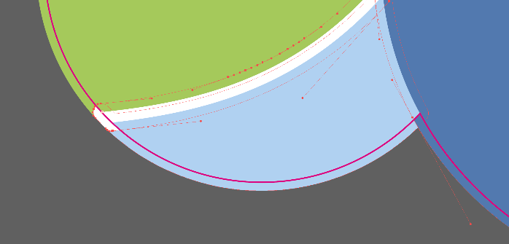 

**Step 5 – Create production-ready PDF file**

1. Select the Artboard Tool

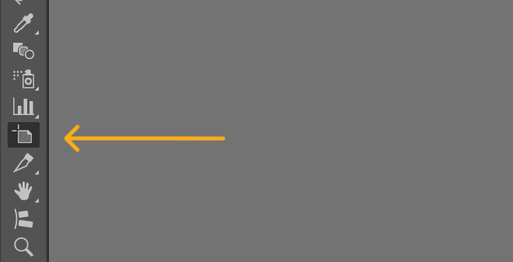

1. While holding down Shift, click on the bleed. This should create an artboard that fits the bleed. If you already have an artboard that you need to replace, double click instead.

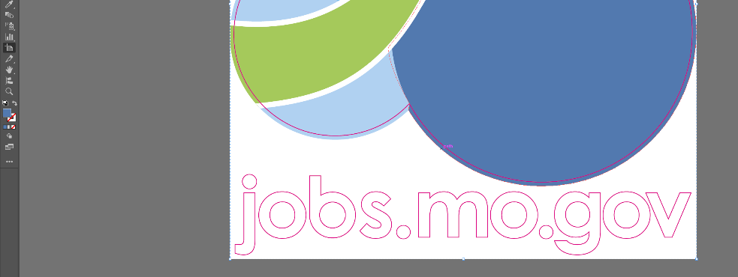

1. Go to File > Save As or press Ctrl/Cmd + Shift + S
2. Name the file with the typical naming structure for high res files (reference *Guide to Client Files* for more information on file name conventions), but with the addition of PRINTCUT (see below).
3. Select Adobe PDF from the drop-down menu
4. Make sure the range of artboards is set to only include the artboard you just created for the high res art. So if your high res art is on artboard 2, set the range to 2.

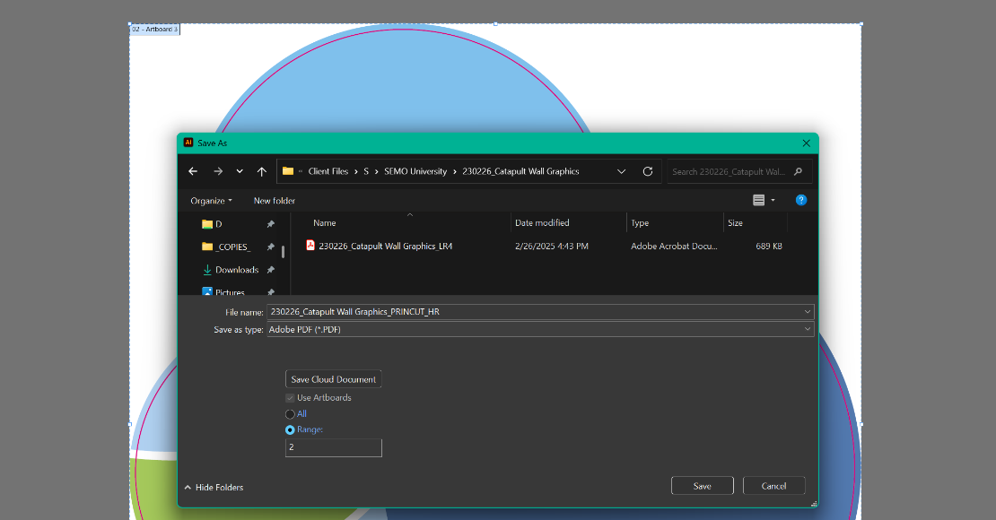

**Additional References**

📌 **Related Documents:**

* **Guide to Client Files** – A guide on how to use the Client Files server.
* **Setting up Vinyl Stickers** – A how-to on setting up stickers for print/cut.